

**Experimental Lab Student Report**

Week 2 Lab

Lab Title: Software Components

Student Name: Anthony Meunier

Date: 1/13/2014

After completing the activities, take a screenshot of the following and copy onto this report:

1. Activity 2-1, after #2 (12 points)

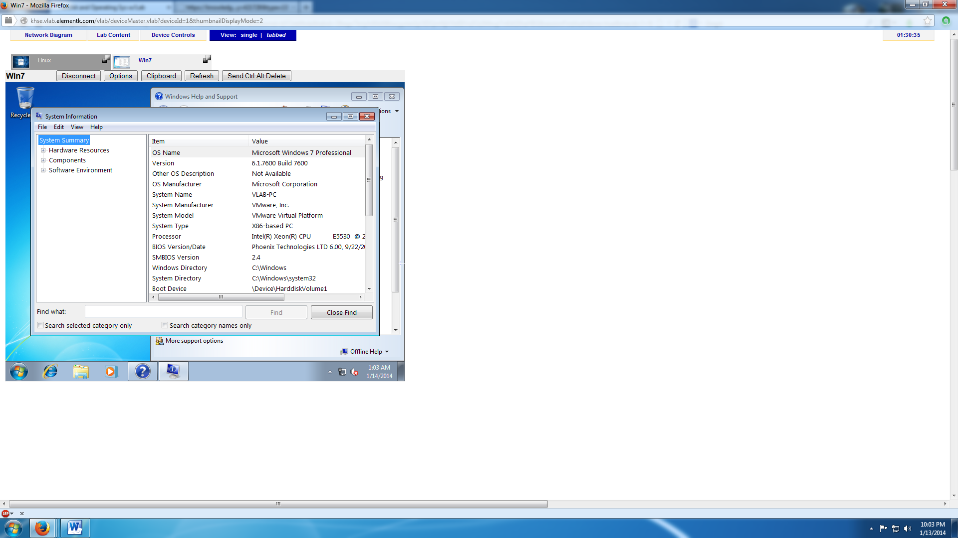

1. Activity 2-2, after #3 (12 points)

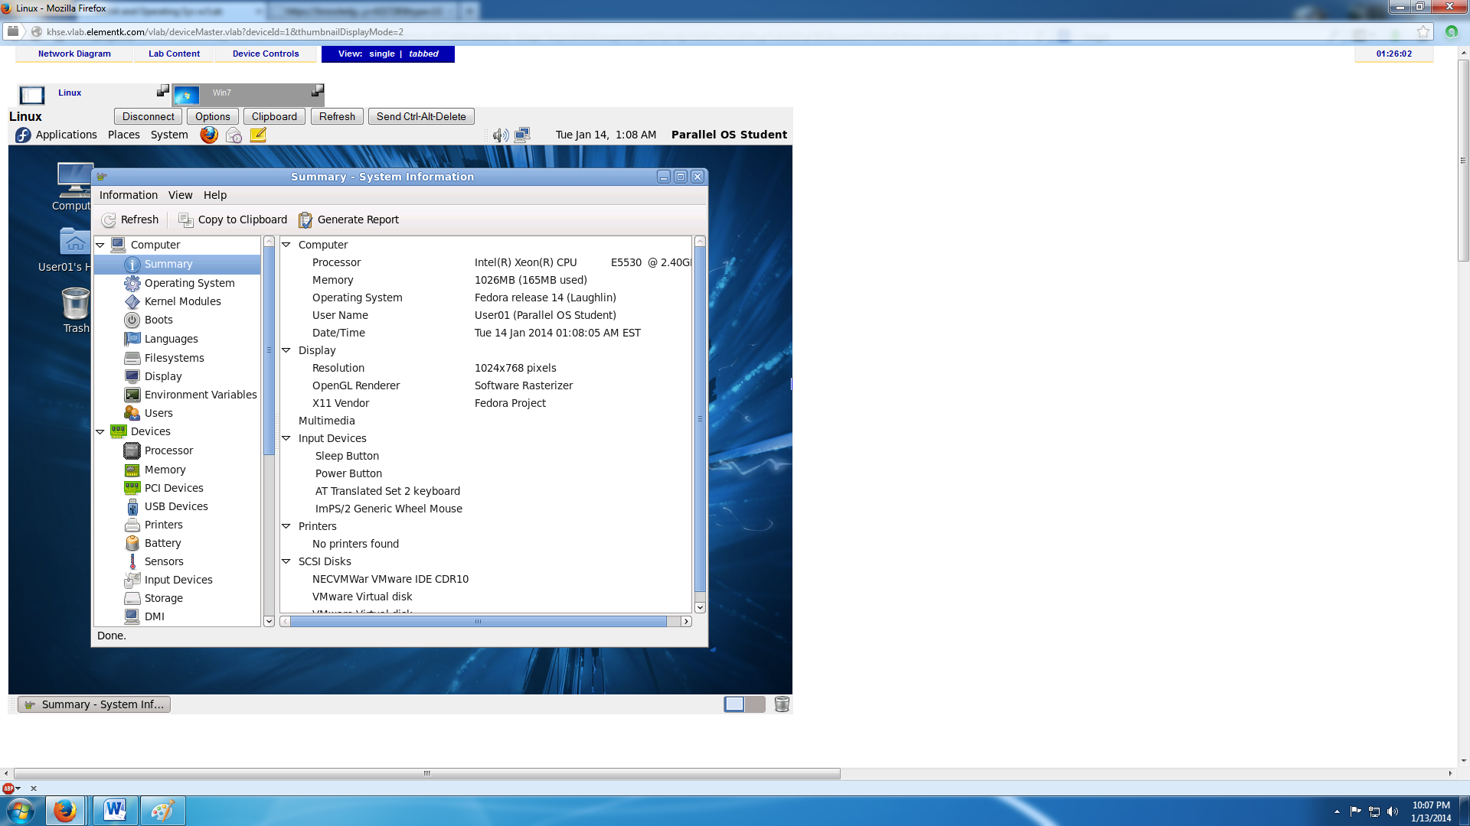

1. Activity 2-3 after the first sentence of #13 (13 points)

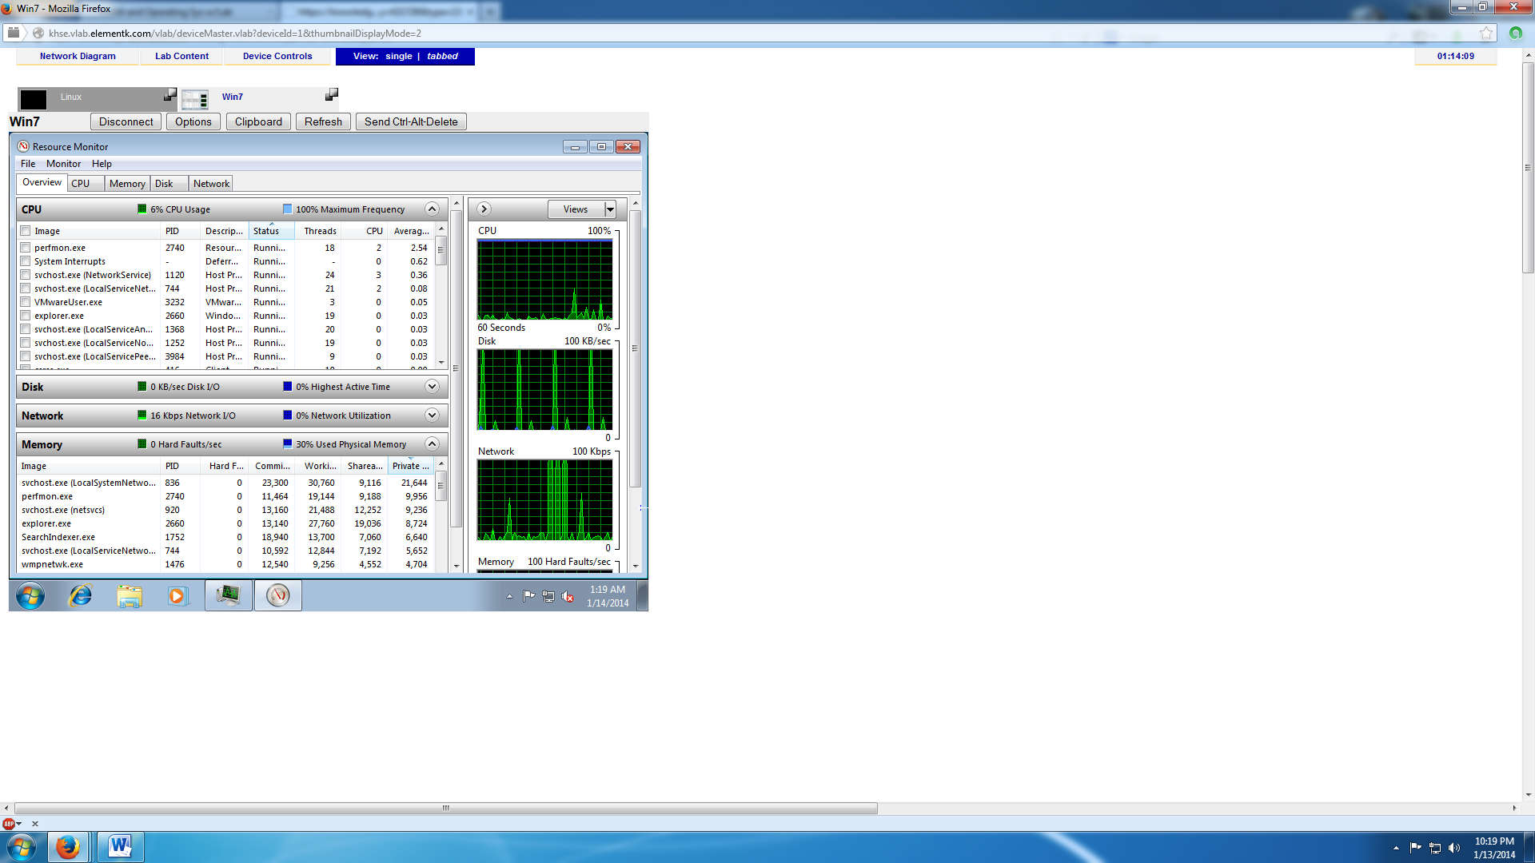

1. Activity 2-4, after #6 (13 points)

